 |  |  |  | Application form  ''Maritime Security'' Common Module  Hellenic Naval Academy-ATHENS/GREECE  27th – 31st March 2023 |  |  | 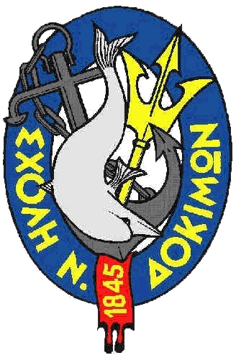
Male |  | Female | Rank |  | Family name | First name

Date of birth | Nationality | Passport number | Passport expiration date

Branch of Service (if available) | Sending institution

line number (if available) | Mobile phone number | e-mail address
Arrival at  Athens Airport | Other Arrival | On (arrival date) | at (arrival time [if available])
* | * | * | *
Departure from  Athens Airport | Other Departure | On (departure date) | At (departure time [if available])
* | * | * | *

Special dietary or food restrictions due to medical or religious reasons | If yes, please specify food you can not eat

Additional remarks (need for special equipment, special travel arrangements, ….)

Point of contact (POC) of sending institute
Male | Female | Rank | Family name | First name
POC’s phone number | POC’s e-mail address

* If you do not know your flight data at this stage you must send them later.
Please send the application form to
Lt. Commander Spyros Lamprou, e-mail address: mil.erasmus@hna.gr

